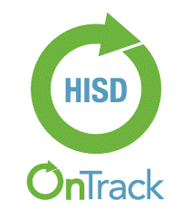****

Dual Language BRR

**`**

**WHY DUAL LANGUAGE BRR?**

As our district strives to develop bi-literate students, our goal is to integrate a holistic approach to measure bilingualism, which embraces fluency in both languages. This holistic methodology is aligned to current dual language research that acknowledges the role of transfer theory and bidirectional transfer (students accessing content learned in both languages and using it to function cognitively). Thus, district administrators, dual language principals and teachers should consider each child's academic progress in a holistic manner. To this end, the benchmarks for achievement for running records have been adjusted for students in dual language classrooms. Teachers who teach dual language should use the following charts to predict and track student achievement.

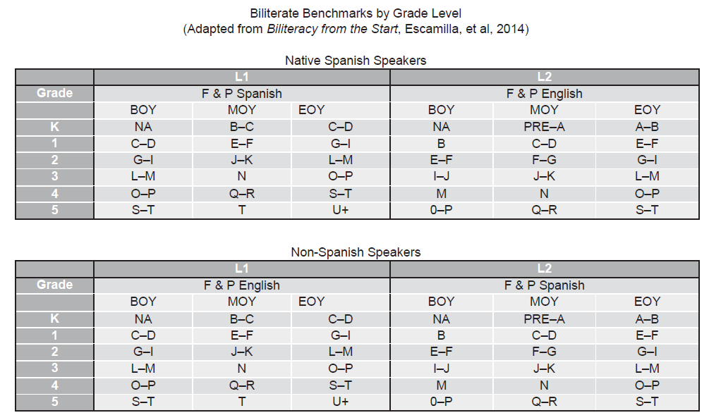

**WHAT IS DL BRR?**

As we transitioned to the OnTrack platform this year and we got solid systems and procedures to record and analyze Running Records Data, we realized during the MOY window that the metrics for the Biliteracy Trajectory for Dual Language Running Records (see charts above) had not been plugged in to the platform. During our MOY window the DL metrics were introduced to the platform by creating 4 assessments exclusive for DL students. Now with DL BRR, Ontrack will allow campuses to digitally capture dual language students’ performance in both languages taking into consideration the biliteracy trajectories. Campuses will have the ability now to populate reports to identify more accurate student needs and allow them to adjust and target their instructional strategies for their Dual Language students in both English and Spanish.

**WHAT WILL BE REQUIRED AND WHEN?**

We ask that all Dual Language campuses enter their EOY Running Records results using the EOY DL BRR Assessments, since the platform now will generate data that reflects if the student needs more development, is meeting expectations or has an advanced development according to the DL Metrics-Biliteracy Trajectory.

While we understand that this may be a new process that we are getting used to, we believe that teachers and administrators will feel encouraged when seeing reports that more accurately reflect their students’ English and Spanish literacy development.

|  |  |
| --- | --- |
| **Date/Window** | **Activity** |
| May 1st – March 25th | DL Campuses enter DL EOY BRR data. |

**USEFUL TECHNICAL INFORMATION:**

**OnTrack Platform Process: Informational website:** [Dual Language BRR](http://www.houstonisd.org/site/default.aspx?PageType=3&ModuleInstanceID=232828&ViewID=7b97f7ed-8e5e-4120-848f-a8b4987d588f&RenderLoc=0&FlexDataID=217383&PageID=133169)

Please refer your teachers to use the task card below in order to ensure they enter their data appropriately.

[Benchmark Running Records Dual Language Task Card](https://houstonisd.sharepoint.com/:w:/r/sites/FormativeAssessmentTeam/_layouts/15/Doc.aspx?sourcedoc=%7B364a02de-11ba-4295-9abb-21a7cc50dae5%7D&action=default)

**WHO DO I CONTACT FOR QUESTIONS AND SUPPORT?**

|  |  |
| --- | --- |
| **ML Dual Language Team 713.556.6961** | **Student Assessment Formative Team 713.349.7460** |
| Xochitl M. Lege [xmaya1@houstonisd.org](mailto:xmaya1@houstonisd.org)  Nubia Parsons [nparson@houstonisd.org](mailto:nparson@houstonisd.org)  Priscilla Chavera [pchavera@houstonisd.org](mailto:pchavera@houstonisd.org)  Evelyn Martinez [Evelyn.Martinez@houstonisd.org](mailto:Evelyn.Martinez@houstonisd.org) | Betty Garcia- Hill [bgarci11@houstonisd.org](mailto:bgarci11@houstonisd.org)  Zulema Mazloom [Zulema.mazloom@houstonisd.org](mailto:Zulema.mazloom@houstonisd.org) |